Exterior Angle Sum Theorem
# Source: AI Source: Provided by: [Data Path: Persons Table -> ID Column: 1, Name_En Column: Motasem Essam] -> From: [ChatGPT] on [7/25/2026]
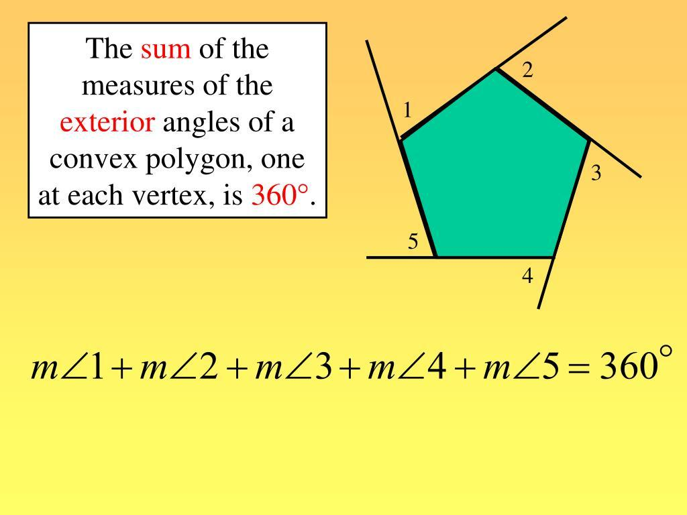
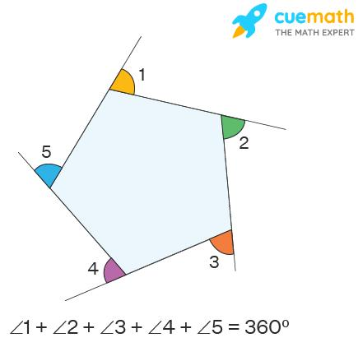
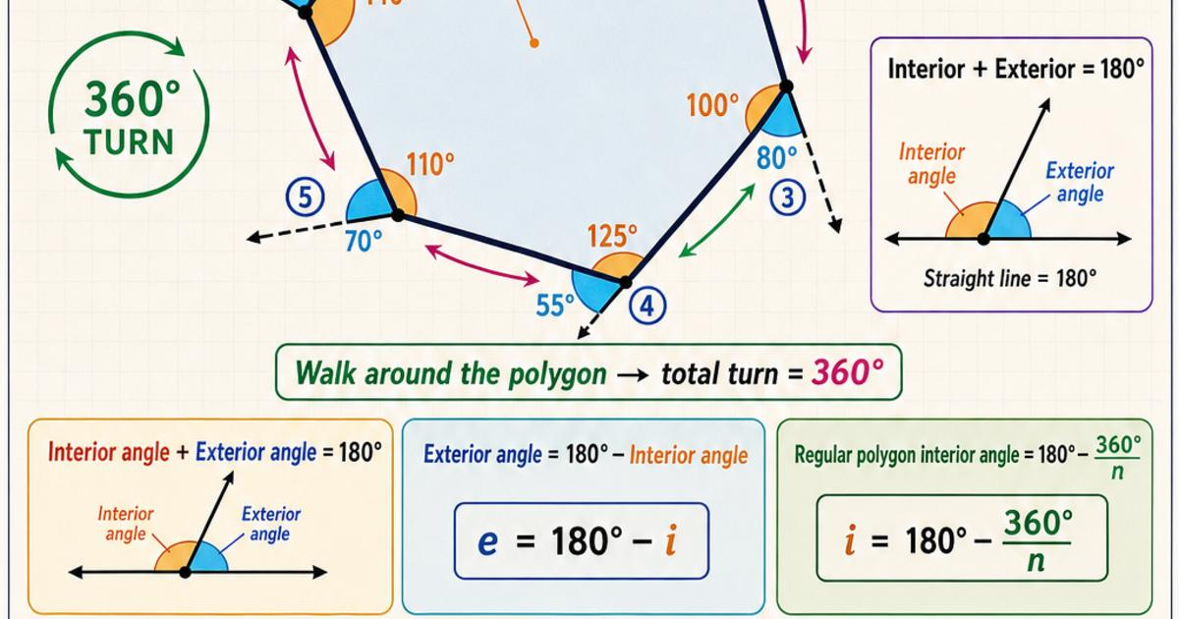
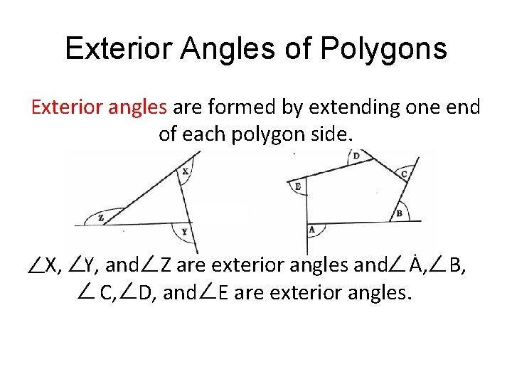

Definition
# Source: AI Source: Provided by: [Data Path: Persons Table -> ID Column: 1, Name_En Column: Motasem Essam] -> From: [ChatGPT] on [7/25/2026]
The Exterior Angle Sum Theorem states that the sum of one exterior angle at each vertex of any simple convex polygon is:
$$\boxed{{360}^{∘}}$$
More generally, for a simple polygon, the sum of the turning angles around its boundary is ${360}^{∘}$, although for concave polygons the convention for exterior angles must be handled carefully.

Fundamental Concept
# Source: AI Source: Provided by: [Data Path: Persons Table -> ID Column: 1, Name_En Column: Motasem Essam] -> From: [ChatGPT] on [7/25/2026]
An exterior angle is formed by one side of a polygon and the extension of an adjacent side.
For a convex polygon:
$$\text{Interior Angle}+\text{Exterior Angle}={180}^{∘}$$
Therefore:
$$E={180}^{∘}-I$$
where:
- $I$= interior angle
- $E$= exterior angle

Theorem
# Source: AI Source: Provided by: [Data Path: Persons Table -> ID Column: 1, Name_En Column: Motasem Essam] -> From: [ChatGPT] on [7/25/2026]
For a convex polygon with $n$sides:
$$\boxed{E_{1}+E_{2}+⋯+E_{n}={360}^{∘}}$$
The result is independent of the number of sides.

Triangle → 360°
Quadrilateral → 360°
Pentagon → 360°
Hexagon → 360°
Octagon → 360°
Decagon → 360°

Proof Using the Interior Angle Sum Theorem
# Source: AI Source: Provided by: [Data Path: Persons Table -> ID Column: 1, Name_En Column: Motasem Essam] -> From: [ChatGPT] on [7/25/2026]
For an $n$-sided polygon, the interior angle sum is:
$$\left(n-2\right){180}^{∘}$$
Since each exterior angle and its corresponding interior angle form a linear pair:
$$I_{i}+E_{i}={180}^{∘}$$
For all $n$vertices:
$$\sum{I}+\sum{E}=180n$$
Substitute the interior-angle sum:
$$\left(n-2\right){180}^{∘}+\sum{E}=180n$$
Therefore:
$$\sum{E}=180n-180\left(n-2\right) \\ \sum{E}={360}^{∘}$$
Thus:
$$\boxed{\sum{E}={360}^{∘}}$$

Regular Polygon
# Source: AI Source: Provided by: [Data Path: Persons Table -> ID Column: 1, Name_En Column: Motasem Essam] -> From: [ChatGPT] on [7/25/2026]
For a regular polygon, all exterior angles are equal.
Therefore:
$$\boxed{E=\frac{{360}^{∘}}{n}}$$
Example: Regular Pentagon
A pentagon has:
$$n=5$$
So each exterior angle is:
$$E=\frac{{360}^{∘}}{5} \\ \boxed{E={72}^{∘}}$$
The five exterior angles then give:
$$5\left({72}^{∘}\right)={360}^{∘}$$

Examples
# Source: AI Source: Provided by: [Data Path: Persons Table -> ID Column: 1, Name_En Column: Motasem Essam] -> From: [ChatGPT] on [7/25/2026]
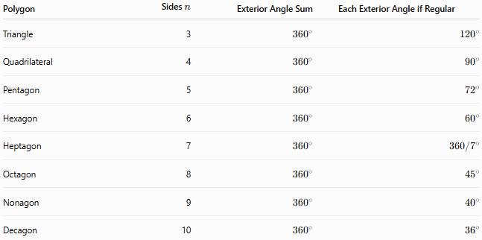
Polygon | Sides $n$ | Exterior Angle Sum | Each Exterior Angle if Regular
Triangle | 3 | $${360}^{∘}$$ | $${120}^{∘}$$
Quadrilateral | 4 | $${360}^{∘}$$ | $${90}^{∘}$$
Pentagon | 5 | $${360}^{∘}$$ | $${72}^{∘}$$
Hexagon | 6 | $${360}^{∘}$$ | $${60}^{∘}$$
Heptagon | 7 | $${360}^{∘}$$ | $$360/7^{∘}$$
Octagon | 8 | $${360}^{∘}$$ | $${45}^{∘}$$
Nonagon | 9 | $${360}^{∘}$$ | $${40}^{∘}$$
Decagon | 10 | $${360}^{∘}$$ | $${36}^{∘}$$

Turning-Angle Interpretation
# Source: AI Source: Provided by: [Data Path: Persons Table -> ID Column: 1, Name_En Column: Motasem Essam] -> From: [ChatGPT] on [7/25/2026]
Another way to understand the theorem is through turning.
As you travel around a convex polygon, you turn at every vertex. The total amount of turning required to return to your original direction is one complete rotation:
$$\boxed{{360}^{∘}}$$
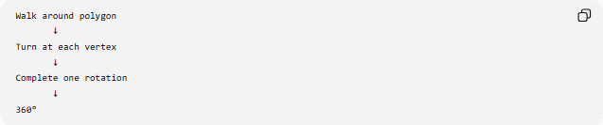
Walk around polygon
↓
Turn at each vertex
↓
Complete one rotation
↓
360°
This is why the exterior-angle sum does not depend on $n$.

Relationship with Interior Angles
# Source: AI Source: Provided by: [Data Path: Persons Table -> ID Column: 1, Name_En Column: Motasem Essam] -> From: [ChatGPT] on [7/25/2026]
For each vertex:
$$I+E={180}^{∘}$$
Therefore:
$$\boxed{E={180}^{∘}-I}$$
For a regular polygon:
$$I=\frac{\left(n-2\right){180}^{∘}}{n}$$
and:
$$E=\frac{{360}^{∘}}{n}$$
so:
$$\boxed{I+E={180}^{∘}}$$

Important Distinction
# Source: AI Source: Provided by: [Data Path: Persons Table -> ID Column: 1, Name_En Column: Motasem Essam] -> From: [ChatGPT] on [7/25/2026]
There are two related ideas:
Exterior Angle Sum
For a convex polygon, using the standard exterior-angle convention:
$$\boxed{{360}^{∘}}$$
Turning Angle Sum
For a simple polygon traversed consistently around its boundary, the signed turning angles have total:
$$\boxed{±{360}^{∘}}$$
depending on traversal direction.
This distinction becomes important for concave and self-intersecting polygons.

Relationship to Polygon Theorems
# Source: AI Source: Provided by: [Data Path: Persons Table -> ID Column: 1, Name_En Column: Motasem Essam] -> From: [ChatGPT] on [7/25/2026]
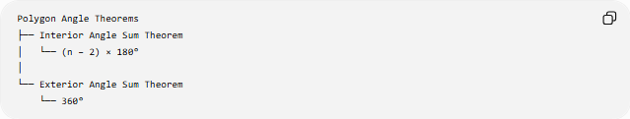
Polygon Angle Theorems
├── Interior Angle Sum Theorem
│ └── (n − 2) × 180°
│
└── Exterior Angle Sum Theorem
└── 360°
For regular polygons:
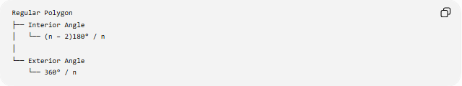
Regular Polygon
├── Interior Angle
│ └── (n − 2)180° / n
│
└── Exterior Angle
└── 360° / n

Key Points
# Source: AI Source: Provided by: [Data Path: Persons Table -> ID Column: 1, Name_En Column: Motasem Essam] -> From: [ChatGPT] on [7/25/2026]
- The exterior angles of a convex polygon sum to ${360}^{∘}$.
- This represents one complete rotation.
- For a regular $n$-gon, each exterior angle is:
$$\boxed{\frac{{360}^{∘}}{n}}$$
- Each interior and exterior angle form a linear pair:
$$\boxed{I+E={180}^{∘}}$$
- The theorem is closely related to the Interior Angle Sum Theorem.
- For concave or self-intersecting polygons, the precise definition of exterior angle must be specified.

Conclusion
# Source: AI Source: Provided by: [Data Path: Persons Table -> ID Column: 1, Name_En Column: Motasem Essam] -> From: [ChatGPT] on [7/25/2026]
The Exterior Angle Sum Theorem states that the exterior angles of a convex polygon make one complete turn around the polygon:
$$\boxed{\sum{E}={360}^{∘}}$$
For a regular $n$-gon, this immediately gives:
$$\boxed{E=\frac{{360}^{∘}}{n}}$$

